**MySQL Week 6 Coding Assignment**

**Coding Steps:**

In this week's coding activity, you will create a menu driven application backed by a MySQL database.

To start, choose one item that you like. It could be vehicles, sports, foods, etc....

Create a new Java project in Eclipse.

Create a SQL script in the project to create a database with one table. The table should be the item you picked.

Write a Java menu driven application that allows you to perform all four CRUD operations on your table.

**Tips:**

The application does not need to be as complex as the example in the video curriculum.

You need an option for each of the CRUD operations (Create, Read, Update, and Delete).

Remember that PreparedStatment.executeQuery() is only for Reading data and .executeUpdate() is used for Creating, Updating, and Deleting data.

Remember that both parameters on PreparedStatements and the ResultSet columns are based on indexes that start with 1, not 0.

**Screenshots of Code:**

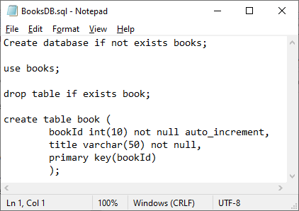

|  |  |
| --- | --- |
|  |  |
|  |  |

**Screenshots of Running Application:**

|  |  |
| --- | --- |
| Menu  ------------------------  1- Add a book  2- Update name of a book  3- List all books  4- Delete a book  5- Exit program  Enter a selection: 1  Enter the title of the book you would like to add: First Book  Menu  ------------------------  1- Add a book  2- Update name of a book  3- List all books  4- Delete a book  5- Exit program  Enter a selection: 1  Enter the title of the book you would like to add: Second Book  Menu  ------------------------  1- Add a book  2- Update name of a book  3- List all books  4- Delete a book  5- Exit program  Enter a selection: 1  Enter the title of the book you would like to add: Book to Delete  Menu  ------------------------  1- Add a book  2- Update name of a book  3- List all books  4- Delete a book  5- Exit program  Enter a selection: 1  Enter the title of the book you would like to add: Book to change  Menu  ------------------------  1- Add a book  2- Update name of a book  3- List all books  4- Delete a book  5- Exit program  Enter a selection: 3  ID # 1 Title: First Book  ID # 2 Title: Second Book  ID # 3 Title: Book to Delete  ID # 4 Title: Book to change | Menu  ------------------------  1- Add a book  2- Update name of a book  3- List all books  4- Delete a book  5- Exit program  Enter a selection: 4  Enter the ID # of the book you would like to delete: 3  Menu  ------------------------  1- Add a book  2- Update name of a book  3- List all books  4- Delete a book  5- Exit program  Enter a selection: 2  ID # 1 Title: First Book  ID # 2 Title: Second Book  ID # 4 Title: Book to change  Enter the ID # of the book you would like to change: 4  Enter the new corrected title: Changed Book  Menu  ------------------------  1- Add a book  2- Update name of a book  3- List all books  4- Delete a book  5- Exit program  Enter a selection: 3  ID # 1 Title: First Book  ID # 2 Title: Second Book  ID # 4 Title: Changed Book  Menu  ------------------------  1- Add a book  2- Update name of a book  3- List all books  4- Delete a book  5- Exit program  Enter a selection: 5  Have a nice day  Press any key to exit |

**URL to GitHub Repository:**

https://github.com/RebeccaGimbel/MySQLWeek5.git